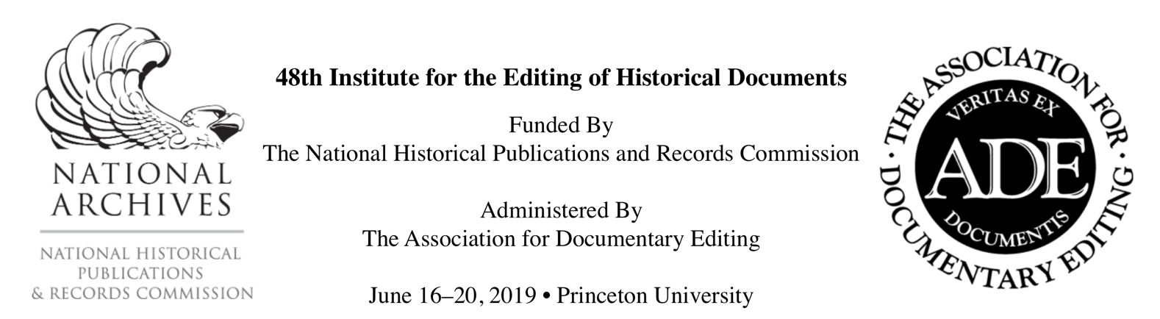

Application Form (MS Word)

The Association for Documentary Editing (ADE) welcomes applications for the 48th Institute for the Editing of Historical Documents (IEHD), to be held June 16 – 20, 2019, on the campus of Princeton University.

The Editing Institute charges no tuition, and travel stipends of $1200 will be provided to eligible participants living outside the immediate Princeton area, free registration to attend the Annual Meeting, and a one-year membership in the ADE. Admission, however, is competitive. For more information about the IEHD, please see the full application announcement or email Nikolaus Wasmoen, ADE Education Director (nlwasmoe@buffalo.edu).

You can apply using the online form, or the offline application form below, which you should submit by email as an attachment to nlwasmoe@buffalo.edu. Please include "IEHD Application for [Full Name]" in the subject line. The deadline for applications is February 1, 2019.

The Institute for the Editing of Historical Documents is administered by the Association for Documentary Editing under a grant from the National Historical Publications and Records Commission (NHPRC), an affiliate of the National Archives and Records Administration (NARA).

Personal Info

First Name
Last Name
Address 1
Address 2
City
State/Province
Zip/Postal Code
Country
Email
Phone
Occupation
Job Title/
Academic Standing
Institutional Affiliation/ Employer
Duties
Colleges or Universities Attended, Degrees, and Years Conferred
Publications (if any)

Documentary Editing Experience (if any; please give project titles, job titles, duties, and dates)

If admitted to the Editing Institute, do you plan to attend the ADE's 2019 Annual Meeting, held at the same location immediately after the Editing Institute? (Y/N)

Professional or Academic Reference

Reference: Full Name
Reference: Title
Reference: Email
Reference: Phone

About Your Project or Proposal

Project or Proposal Title
Project Abstract (1-2 sentences)

Identify three topics or challenges in relationship to your project
that you want to learn more about at the Editing Institute.

Challenge/Topic 1
Challenge/Topic 2
Challenge/Topic 3

Essay (max 600 words)

Instructions: Please explain your reasons for wanting to attend the Editing Institute (1–2 pages). Describe in detail your ongoing work editing historical documents. Give particular attention to the nature and content of your documents as well as the scope of your project. Be sure to assert the historical importance of the materials that you plan to publish. Indicate the extent of institutional support for your project, sources of outside funding (in place or hoped for), the amount of work already completed, and any other information that you think might be helpful.

If applying as a prospective teacher of documentary editing, describe in detail your ongoing work as an instructor, your experience working with historical documents, and your plans for incorporating a course in documentary editing into your institution’s curriculum. Be sure to demonstrate how such a course will complement existing offerings. Indicate the extent of institutional support for your plans, the amount of work already completed, and any other information that you think might be helpful.

Knowledge of Documentary Editing

On a scale of 0 to 3—where 0 = no clue, 1 = basic understanding, 2 = working knowledge, and 3 = expert—rate your level of familiarity with the following tasks and tools.

Collection
Control
Selection
Digitization
Transcription
Encoding
Indexing
Annotation
Proofreading
Verification
Copyright and Permissions
Layout
Copyediting
Tagging
Print Design
Web Design
XML
TEI
HTML
CSS
Omeka
Drupal

